MIGRATION, BORDER GEOGRAPHIES and DECOLONIAL MOVEMENTS

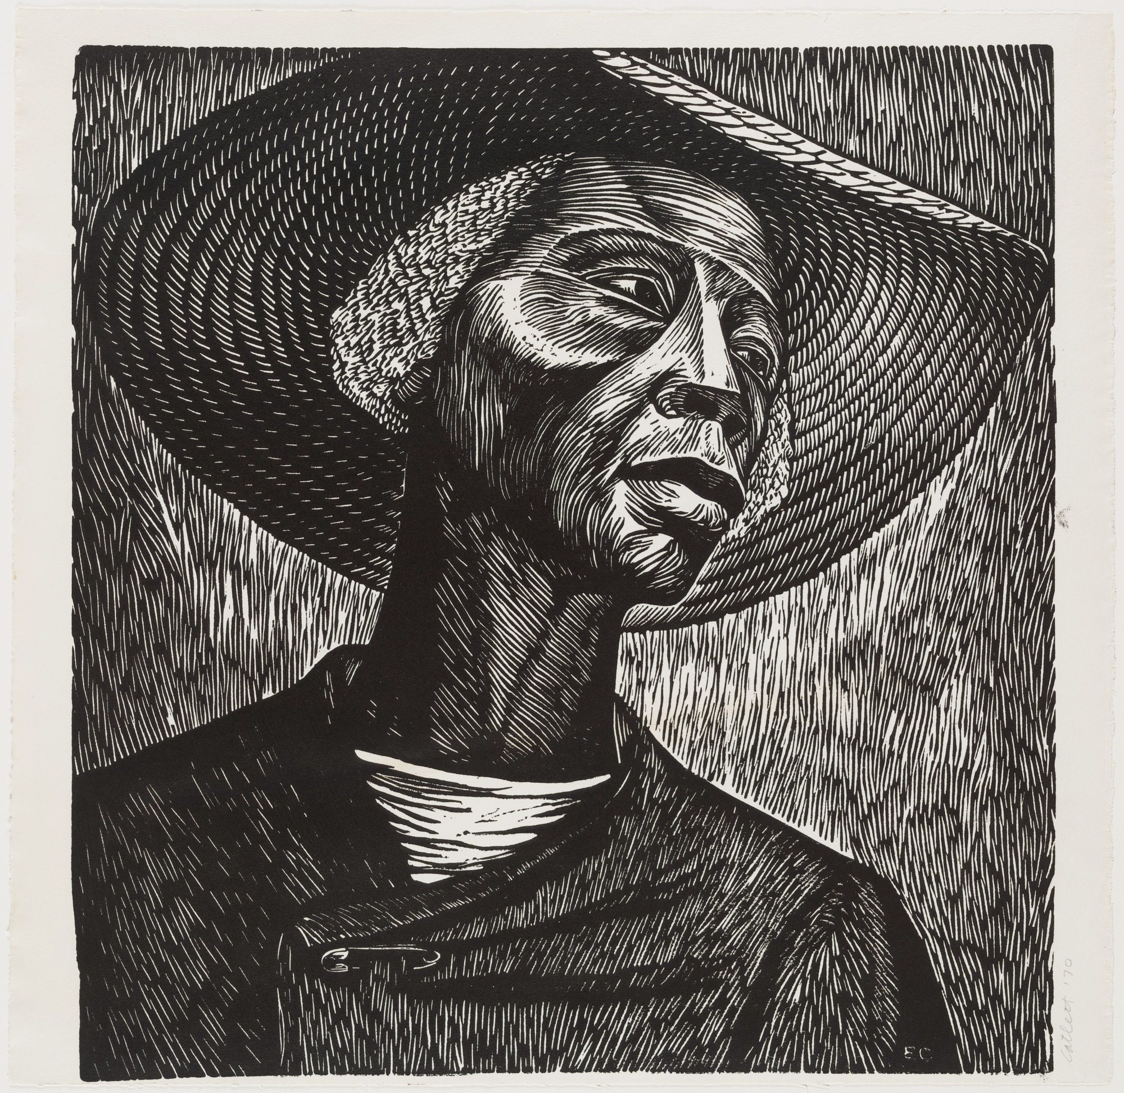
Sharecropper (1952)
Elizabeth Catlett (Washington D.C. 1915-Cuernavaca, Mexico 2012)

Instructor: Diana Negrín da Silva
Email: diananegrin@berkeley.edu

COURSE DESCRIPTION
This course examines how today’s Latinx geographies were shaped by racialized and regionalized discourse and practice, setting the foundation for contemporary struggles over political, economic and social borders and identities along and across the Latin American diaspora. Specifically, the course incorporates the study of the United States’ relationship with Mexico, Central America, and the Caribbean in order to understand how these histories map onto the productions of borders, regimes of migration and citizenship, and movements that increasingly articulate a decolonial turn in intellectual thought and within political and social action. We begin by exploring Mesoamerica and the Caribbean as physical and human spaces that were profoundly reshaped by European colonization and the imposition of new, yet distinct forms of racial and ethnic identifications. We will then survey how land ownership, political and economic power, and social movements shaped these places and countries. These histories will be read alongside the U.S.’s rise as a regional imperial power in order to understand how the immigration of heterogeneous peoples from these countries to the U.S. reflects a troubled relationship manifested in today’s migration policies and binary identities. We conclude with an examination of the emergence of decolonial intellectual, political and social movements both south of the U.S. border as well as within Latinx communities in the United States, paying close attention to the ways blackness, indigeneity and Latinidad intersect and diverge through space, identity and place.

COURSE REQUIREMENTS
Attendance and Participation:
Students are expected to attend all lectures and discussion sections. Please advise your GSI of any expected absences. A maximum of 2 excused absences are allowed per section. Attendance and participation will make up 20% of the final grade and attendance will take place at the beginning of every section. Class participation grade is based on each student’s critical and respectful engagement with the course material and one pop quiz will be carried out in section. Please come having done all of the reading and ready to participate.

Exam 1 (September 25th): In-class exam with identifications, short answers and short essays. The content will deal with the first series of course themes detailing foundational geographies and historicies of the Mesoamerican and Caribbean regions. This includes pre-conquest geographies, colonial racial formations, the creation of the U.S.-Mexico border and the rise of the U.S. as a regional imperial force.

Exam2 (November 6): Take-home exam in the form of an essay. Students will be able to chose between three distinct questions. Themes will include regional political transformation in the 20th century, the Cold War, immigration politics, migrant labor, and the construction of a policed southern border. More details to follow.

Final Exam (TBD): Take home research paper based on specific topics covered in Unit 3 (See prompt)

ASSIGNMENTS & GRADE BREAKDOWN
Section attendance and participation = 20%
Exam 1 (in class) = 20%
Exam 2 (take home) = 25%
Final (in class) = 25%
Quiz = 10%

COURSE READINGS
We will have one reader and the following books:
Danticat, Edwidge. 2008. Brother, I’m Dying. Vintage Contemporaries.
Zamora, Javier. 2017. Unaccompanied. Port Townsend, WA: Copper Canyon Press.
Reader available at Copy Central, 2411 Telegraph Ave.

CLASSROOM POLICIES
Learning Environment: We will cover various contentious and politicized topics in this course, many of which will be unfolding in real time. While you are not required to hold the same political perspectives as your classmates, GSI, or lecturer, you are required to treat everyone with respect and listen. Our goal is to find ways to engage in constructive dialogues without denying the opinions and experiences that your peers bring to the table.

Come prepared: Bring pens and paper to every lecture and discussion sections for note-taking, writing exercises, and in-class assignments. Take notes! I will not post powerpoint slides on bCourses; engaged listening and note taking are important skills. Readings are essential to this course. Please complete each reading before the lecture for which it is assigned. Films should be treated as text in that they are required and may be included on exams.

Students with Disabilities or Special Needs: Please bring these to my attention through the Disabled Student Program as soon as possible. We will provide all requisite accommodations.

Course Web Site: Our course has a web site at bCourses.berkeley.edu. It is crucial that you check the page regularly for course updates and other announcements.

Laptops and other Digital Devices: The use of laptops and other digital devices during lecture and sections is prohibited. Turn off your smart phones—no texting during lectures or discussion sections. Exceptions to this policy will be made directly with the instructor.

Academic Integrity: Academic integrity is a joint endeavor among not only students but the entire academic community in all scholarship and scholarly activity. In this course each of us is responsible for fostering an environment of honesty, fairness, and respect. UC Berkeley has strict policies concerning academic misconduct and dishonesty. The University defines academic misconduct as “any action or attempted action that may result in creating an unfair academic advantage for oneself or an unfair academic advantage or disadvantage for any other member or members of the academic community” (UC Berkeley Code of Student Conduct). This typically involves the following: (1) plagiarism: copying text or ideas from another source without appropriate reference; and (2) cheating: fraud or dishonesty in an academic assignment, including examinations. Cheating, plagiarism, and other academic misconduct will result in a failing grade on the assignment, paper, quiz, or exam in questions and will be reported to Student Judicial Affairs. For more information about intentional academic misconduct and attendant consequences see: http://advocate.berkeley.edu/conduct/

CLASS SCHEDULE AND READINGS

UNIT ONE—Geographic Foundations, Beyond Coloniality
Pre-conquest geographies, colonial racial formations, the creation of national borders.

WEEK 1—COURSE INTRODUCTION
Thursday, August 29

WEEK 2—REGIONAL GEOGRAPHIC AND HISTORICAL FOUNDATIONS I
Tuesday, September 3—Mesoamerica
Hartman, Saidiya. 2008. Venus in Two Acts. Small Axe 12 (2), p. 1–14.
Mann, Charles C. 2005. 1491: New Revelations of the Americas Before Columbus. Introduction: “A View from Above”, pp. 3-27.
Thursday, September 5—From Tenochtitlan to the Creation of New Spain
Díaz del Castillo, Bernal. 1963. “Arrival in the Splendid City of Tenochtitlan” in The Conquest of New Spain. Translated by J.M. Cohen. Albuquerque, NM: University of New Mexico Press, pp. 156-183.
Mundy, Barbara E. 1996. “Mapping and Describing the New World” in The Mapping of New Spain: Indigenous Cartography and the Maps of the Relaciones Geográficas. Chicago, IL: University of Chicago Press, pp. 11-27.

WEEK 3— REGIONAL GEOGRAPHIC AND HISTORICAL FOUNDATIONS II
Tuesday, September 10—Race and Ethnicity in Colonial New Spain
Carrera, Magali M. 2003. “Envisioning the Colonial Body” Imagining Identity in New Spain: Race, Lineage and the Colonial Body in Portraiture and Casta Paintings. Austin, TX: University of Texas Press, pp. 44-105.
Listen: Claudio Lomnitz on “The History of Racial Identity in Mexico” Latino USA 2016 http://latinousa.org/2016/04/22/claudio-lomnitz-history-racial-identity-mexico/
Thursday, September 12—Colonial Cuba and Revolutionary Haiti
Ferrer, Ada. 2014. Freedom’s Mirror: Cuba and Haiti in the Age of Revolution. Cambridge University Press. “Introduction: The Haitian Revolution and Cuban Slave Society” 1-16, “Epilogue: Haiti, Cuba, and History: Antislavery and the Afterlives of Revolution” 329-346.

WEEK 4—RACIALIZING THE BORDERLANDS
Tuesday, September 17—Afro-Latinxs at the Borderlands
Forbes, Jack D. 2010. “Black Pioneers: The Spanish-Speaking Afro-Americans of the Southwest.” The Afro-Latin@ Reader: History and Culture in the United States. Miriam Jiménez-Román and Juan Flores, eds. Durham, NC: Duke University Press, ps. 27-37.
Greenbaum, Susan D. 2010. “Afro-Cubans in Tampa”. The Afro-Latin@ Reader: History and Culture in the United States. Miriam Jiménez-Román and Juan Flores, eds. Durham, NC: Duke University Press, ps. 51-61.
Thursday, September 19—Manifest Destiny and White Supremacy on the Frontier
Walker, Dale. 1999. Bear Flag Rising: The Conquest of California, 1846. Forge Books, “Los Osos”, pp. 116-130.

WEEK 5—US HEGEMONY & THE PRODUCTION OF THE SOUTHERN FRONTIER
Tuesday, September 24— U.S. Intervention, from 1898 to the Cold War
Kinzer, Steve. 2006. Overthrow: America’s Century of Regime Change from Hawaii to Iraq. New York, NY: Times Books. Selections, pp. 31-55, 127-147.
Neruda, Pablo. 1950. “La United Fruit Company” (1950).
Alegría, Claribel. 2013. Halting Steps: Collected and New Poems. Evenston, IL: Curbstone Books/Northwestern University Press. Selections.
Listen: “A Brief History of the U.S. in Central America” in Latino USA, September 12, 2014. http://latinousa.org/2014/09/12/roots-child-migrant-crisis/

Thursday, September 26—Creating the US-Mexico Border
Nevins, Joseph. 2003. Operation Gatekeeper and Beyond: The War on Illegals and the Remaking of the U.S.-Mexico Boundary. “Local Context and the Creation of Difference in the Border Region” and “The Effects and Significance of the Bounding of the United States”, pp.123-149. New York: Routledge.
St. John, Rachel. 2011. A Line in the Sand: A History of the Western U.S.-Mexico Border. Princeton, NJ: Princeton University Press, chapter 3 “Landscape of Profits”, pp.63-89 and chapter 4 “The Space Between”, pp. 90-118.

UNIT TWO—Hemispheric Migrations
20th Century political transformations, immigration policy across borders and the militarization of the southern border

WEEK 6—DEFYING EXPECTATIONS
Tuesday, October 1—Migrations and Afro-latinidad
Mann-Hamilton, Ryann. 2010. “Retracing Migration: From Samaná to New York and Back Again.” The Afro-Latin@ Reader, ps. 422-425.
Lambert, Aida. 2010. “We Are Black Too: Experiences of an Honduran Garífuna.” The Afro-Latin@ Reader, ps. 431-433.
Guzmán, Pablo Yoruba. 2010. “Before People Called Me a Spic, They Called Me a N-----.” The Afro-Latin@ Reader, ps. 235-243.
Haslip-Viera, Gabriel. 2010. “Changing Identities: An Afro-Latin@ Family Portrait.” The Afro-Latin@ Reader, ps. 142-149.
Thursday October 3—Mexico as destination and the ‘vertical border’
Chao Romero, Roberto. 2010. The Chinese in Mexico, 1882-1940. Tucson, AZ: University of Arizona Press. “Introduction”, pp.1-11, “Conclusion”, 191-197.
A comparative reading on refugees in Mexico

WEEK 7— RACIALIZING AND MILITARIZING IMMIGRATION
Tuesday, October 8— Haiti and the Production of Racialized Policy
Loyd, Jenna and Alison Mountz. 2018. Boats, Borders, and Bases: Race, the Cold War, and the Rise of Migration Detention in the United States. Berkeley, CA: University of California Press. “America’s Boat People”, pp. 31-53.
Danticat, Edwidge. 2008. Brother, I’m Dying. Vintage Contemporaries. Selections.
Thursday, October 10—Detention and Militarization
Loyd, Jenna and Alison Mountz. 2018. Boats, Borders, and Bases: Race, the Cold War, and the Rise of Migration Detention in the United States. Berkeley, CA: University of California Press. “Part III: Expanding the World’s Biggest Detention System”, pp. 145-200, 220-236
Danticat, Edwidge. 2008. Brother, I’m Dying. Vintage Contemporaries. Selections.

WEEK 8—FLIGHT AND HOPE ACROSS THE SOUTHERN BORDER
Tuesday October 15—Life and Death at the Border
De León, Jason. 2015. The Land of Open Graves. Berkeley, CA: UC Press. “Chapter 1: Prevention Through Deterrence”, pp. 23-37.
Zamora, Javier. 2017. Unaccompanied. Port Townsend, WA: Copper Canyon Press. Selections
Thursday October 17—Hope, Roots and Routes
Cruz-Manjarrez, Adriana. 2013. Zapotecs on the Move: Cultural, Social, and Political Processes in Transnational Perspective. Rutgers University Press. Chapter 1: “The Yalaga Zapotecs: A Town of Immigrants”; Chapter 2: “Building Community and Connections in Los Angeles”; Chapter 3: “Community Life Across Borders”, ps. 20-96.

UNIT THREE—Theorizing from the Borderlands
Decolonial theorizations from the diaspora and the borderlands

WEEK 9—TOWARD A “NEW SCIENCE OF THE WORD”
Tuesday, October 22—Sylvia Wynter and the Caribbean borderlands
Wynter, Sylvia. 2003. “Unsettling the Coloniality of Being/Power/Truth/Freedom: Towards the Human, After Man, Its Overrepresentation—An Argument.” CR: The New Centennial Review, 3(3), ps. 257-337.
Thursday, October 24—Gloria Anzaldúa and the Southwest borderlands
Anzaldúa, Gloria. 2010. “Movimientos de eebeldía y las culturas que traicionan.” Race/Ethnicity: Multidisciplinary Contexts, 4(1), ps. 1-7.
Pérez, Emma. 2005. “Gloria Anzaldúa: La Gran Nueva Mestiza Theorist, Writer, Activist-Scholar. NWSA Journal, 17(2), p. 1-10.

WEEK 10—ANZALDUAN THEORIZATIONS AND (DE)COLONIALITY
Tuesday, November 5—Anzaldúa Across Disciplines
Kaiser Ortíz, John. 2016. “Gloria Anzaldúa and the Problem of Violence Against Women.” philoSOPHIA, 6(2), ps. 195-213.
Solis Ybarra, Priscilla. 2009. “Borderlands as Bioregion: Jovita González, Gloria Anzaldúa, and the Twentieth-Century Ecological Revolution in the Río Grande Valley.” MELUS: Multi-Ethnic Literature of the U.S., 34(2) 175-189.
Thursday, November 7—The Border Colonial
Hernández, Roberto D. 2018. Coloniality of the US///Mexico Border: Power, Violence, and the Decolonial Imperative. Tucson, AZ: University of Arizona Press. Introduction: “Coloniality of Power, Violence, and the U-S///Mexico Border”, ps. 3-35.

WEEK 11—BORDERS, VIOLENCE AND THE CREATION OF ILLEGALITY
Tuesday, November 12—Who Crossed the Border?
Hernández, Roberto D. 2018. Coloniality of the US///Mexico Border: Power, Violence, and the Decolonial Imperative. Tucson, AZ: University of Arizona Press. Chapter 2: “Territorial Violence and the Structural Location of the Border, ps. 67-93.
Morales, Laurel. 2017. “Border wall would cut across land sacred to native tribe” in National Public Radio, February 23, 2017.
Listen: “Border wall would cut across land sacred to native tribe” in National Public Radio, February, 23, 2017. https://www.npr.org/2017/02/23/516477313/border-wall-would-cut-across-land-sacred-to-native-tribe
Thursday, November 14—Families, Identity and the Navigation of Illegality
González, Roberto. 2011. “Learning to be Illegal: Undocumented Youth and Shifting Legal Contexts in the Transition to Adulthood.” In American Sociological Review, 76(4), pp. 602-619.
Negrón-González, Genevieve. 2013. “Navigating “illegality”: Undocumented youth & oppositional consciousness” in Children and Youth Services Review, Number 35, pp. 1284-1290.

UNIT 4—From Theory to Action Across the Latinx Diaspora
Decolonizing identities and political praxis

WEEK 12— DECOLONIZING HISTORY AND IDENTITY
Tuesday, November 21—The Politics of Recognition
Coulthard, Glen Sean. 2009. Red Skin, White Masks: Rejecting the Colonial Politics of Recognition. Minneapolis, University of Minnesota Press. Chapter 1: “Subjects of Empire”, ps. 1-24.; Chapter 5: “The Plunge Into the Chasm of the Past”, ps. 131-150.
Thursday, November 23—Plural Geographies
Bledsoe, Adam and Willie Jamaal Wright. 2018. “The Pluralities of Black Geographies.” Antipode, 51(2), ps. 419-437.

WEEK 13—FROM DISPOSSESSION TO RESISTANCE
Tuesday, November 26 — Globalization and the Zapatista Uprising
Gilly, Adolfo. 1998. “Chiapas and the Rebellion of the Enchanted World” in Rural Revolt in Mexico: U.S. Intervention and the Domain of Subaltern Politics, ed Joseph Nugent. Durham, NC: Duke University Press, pp. 261-333.
Zapatista Army for National Liberation. 1994. “First Declaration of the Lacandon Jungle”.
Thursday, November 28—Thanksgiving Holiday, No class

WEEK 14— Latinx Diasporic Identities
Tuesday, December 3— Latinx identities & political power
Martínez, Elizabeth. 1998. De Colores Means All of Us: Latina Views for a Multi-Colored Century. Cambridge, MA: South End Press, “Whatever Happened to the Chicano Movement?”, pp. 198-203, “Be Down With the Brown.” In pp. 210-219.
Matthews, Theresa. 2018. “Walkout: In 1968 East L.A. Students Led a Movement” in CityLab, https://www.citylab.com/equity/2018/03/walkout-in-1968-east-la-students-led-a-movement/555596/
Thursday, December 5—Musicalizing Hope
Rivera-Rideau, Petra R. 2018. “If I Were You”: Tego Calderón’s Diasporic Interventions. Small Axe, 22(1), ps. 35-69.
Coulthard, Glen Sean. 2009. Red Skin, White Masks: Rejecting the Colonial Politics of Recognition. Minneapolis, University of Minnesota Press. Conclusion. Lessons from Idle No More: The Future of Indigenous Activism, ps. 151-180.

