Diversified Farming Systems: Impacts and Adaptive Responses to the COVID-19 Pandemic in the United States, Norway and China
Inger Elisabeth Måren ¹*, Heidi Wiig ², Kathryn McNeal ³, Sally Wang ⁴, Sebrina Zu ⁵, Ren Cao ⁶, Kathinka Fürst ⁷ and Robin Marsh ⁸

¹ Department of Biological Sciences, University of Bergen, Bergen, Norway, ² Department of Strategy and Entrepreneurship, BI—Norwegian Business School, Oslo, Norway, ³ Department of Geography, University of California, Berkeley, Berkeley, CA, United States, ⁴ Department of Social Science, Duke Kunshan University, Kunshan, China, ⁵ Department of Agriculture and Resource Economics, University of California, Berkeley, Berkeley, CA, United States, ⁶ Department of Geography, San Diego State University, San Diego, CA, United States, ⁷ Norwegian Institute for Water Research (NIVA), Oslo, Norway, ⁸ Institute for the Study of Societal Issues (ISSI), University of California, Berkeley, Berkeley, CA, United States

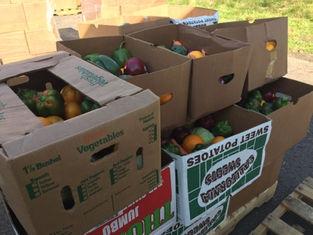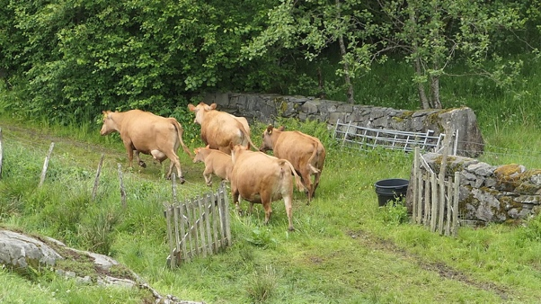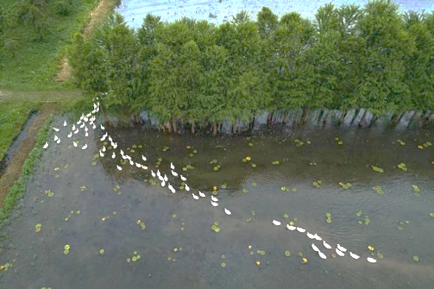

This paper published in Frontiers in Sustainable Food Systems (06/16/2022) offers a unique insight into the global nature of the COVID-19 pandemic by examining impacts and responses in the small farm sector within three very distinct contexts: the United States/California, EU/Norway, and China. We reviewed policy adaptations to understand how governments, the private sector, non-profit organizations, and communities “stepped up” to provide emergency relief and recovery support for farmers, support that was instrumental in preventing more devastating impacts in all three countries. Drawing from in-depth interviews with farmers (23) and government and non-governmental support organizations (19), we mapped the vulnerability and resiliency of selected farmers to shocks that severely disrupted traditional supply chains during the COVID-19 pandemic.

“It’s been very rewarding to be a part of this very broad ‘all hands on deck’ effort to help the agriculture community weather this crisis and to see how many farms and ranches have navigated the waters on their own...Just a tremendous amount of energy has been poured into the crisis response. I hope we can be a part of institutionalizing what good has come out of this so that it doesn’t just sink back into the ground, like water after a short rain.” (University of California County Extension Officer).

Commonalities and Differences Across Countries

The data show commonalities for several of the adaptive responses despite very distinct socio-political systems, most importantly:
- Sharp rise in e-commerce;
- Increased direct and diversified markets to consumers;
- Changes in social norms toward collaboration and re-kindling of community traditions;
- Crucial designation of farmers and farmworkers as “essential”;
- Crucial government emergency and recovery support; and
- Complementary training and logistics support by NGOs and/or the private sector to farmers where government support was lacking.

Across sites a constellation of actors worked in concert to help farmers and the agri-food sector weather the pandemic storm. In China, the major role of Alibaba’s digital platform linking thousands of “scattered” farmers with excess produce to buyers throughout the country was important. In Norway, direct markets and the Norwegian Farmers and Smallholders Association have been the driving force behind the fast growth of REKO-rings, digitally connecting small, diversified farmers directly with individual consumers. And in California, diversified, small and mid-size farms were able to survive and even prosper during the pandemic because of their “nimbleness” in quickly pivoting to direct marketing as demand increased.

Although government policies were enormously important in all three cases in preventing more severe or long-lasting impacts on farmers, such as loss of land and equipment, benefits were hard to access for socially disadvantaged/non-English speaking farmers in the U.S., small, diversified family farmers in Norway, and “scattered farmers” unassociated with government-backed enterprises in China. The necessity of community solidarity together with institutional support for surviving a health crisis affecting the entire planet became apparent. The big question remains as to whether certain positive trends and policies will endure after the pandemic is over. Below we summarize major findings and suggestions for building a more socially, ecologically and economically resilient agri-food system post- pandemic, integrating data from the three sites.

Diversify Markets
With the pandemic, markets were hit directly, so farmers able to pivot quickly to direct marketing did relatively well, and farmers with a diversity of fresh and processed products to offer sheltering-at-home consumers did even better. In addition, several farmers benefited from a break in perceived unfair competition with imported food, especially from Mexico in the case of California, and other EU countries in the case of Norway. Even the YFD Farm in China benefited from closed regional borders adding a new source of local tourism income.

“Yaofeng Dao farm seized this opportunity (the pandemic) to extend their market chain and unite three kinds of industries…We started to rely on social media platforms to do promotions. We use “wechat” mini programs to sell our organic products and use “wechat” public accounts to spread our sustainable farming philosophy.” (YFD farm manager)

Retain Positive Changes in Social Norms
The pandemic put a spotlight on peoples’ essential connections to food and food providers while lockdown restrictions increased demand for locally produced foods that were perceived as safer and more readily available. Farmers involved in direct marketing perceive this as a positive change in social norms that they hope will continue post- pandemic.

“There has been more uncertainty, poor predictability and difficulties related to planning, and the psychological aspect is most prominent, not knowing if the customer base disappears. … Farming costs are high anyways, hence also my product prices, but can struggling restaurants afford to pay? To me this is an ethical dilemma as I have a sense of solidarity with my customers”. (Farmer 1, Norway).

Prioritize Socially Disadvantaged and Small to Midsize Farmers
The findings indicate inequities in impacts, leaning more negative than positive for immigrant farmers (California) and “scattered” subsistence farmers (China). In Norway, the progressive social contract between citizens and their government is nonetheless focused on large operations, and consumers rely heavily on cheaper imported food. In the US, negative impacts were somewhat minimized where NGOs and selected government programs actively targeted socially disadvantaged farmers.

Aim for “Hybrid” Agri-Food System?
The European Union/Norway and China had a unified rapid response to the pandemic to prevent its spread and worsening health and economic impacts, whereas the US’ federal response was delayed leaving much of the heavy lifting to individual states with heavy costs in lives and economic harm. However, in the US, and especially California, the remarkable non-governmental response to the market and supply disruptions—both by farmers and support organizations, reduced harm to small commercial farms and socially disadvantaged farmers and farmworkers. Given these major strengths and weaknesses across three very different societies, it is interesting to contemplate building a “hybrid” crisis response structure that takes the best from each system. Indeed, this comparative study suggests a strong need for such an exercise by policymakers, NGOs and citizens across the world in their deliberations and planning for the next global crisis.

Postscript: The paper analysis is based on field work conducted at the early stage of the COVID outbreak. The situation has shifted and worsened in China until today. COVID also continues to disrupt supply chains in the US and Europe.

Citation: Måren I.E., Wiig, H., McNeal K., Wang S., Zu S., Cao R., Fürst K. & Marsh R. 2022. Diversified Farming Systems: Impacts and Adaptive Responses to the COVID-19 Pandemic. Frontiers in Sustainable Food Systems. https://doi.org/10.3389/fsufs.2022.887707

